**Data to Destiny**

**Introduction**

Data to Destiny is a ed-tech startup that primarily focuses on providing online education courses for Data Analytics. The website based platform is launched on April01,2023 and offers comprehensive learning experience guiding students from basics to advanced learning techniques. The goal of the organization is to bridge the gap between learning and real-world applications enabling the students to achieve great heights in Data Analytics Industry. The organization has the pride on leveraging data-driven insights to implement strategic decisions and improve the organizational efficiency. In line with this Vision the top management officials has initiated detailed analysis project to understand and optimize various aspects of the business including user engagement, course popularity, marketing effectiveness and overall sales performance.

**Objectives**

The main aim of the analysis is to provide the organization with data driven insights on how to improve the marketing strategies that can engage the users for the better course reach that can directly impacts the overall sales performance.

**Datasets to be Used**

* april_data
* may_data
* june_data
* campaigns
* course_price
* campaign_metrics_june
* campaign_metrics_july
* july_data_20230715
* july_data_20230731

**Product Analysis**

**Course S1B1(Statistics)**

* Registrations timeline - 01April2023 till 14April2023.
* Dataset to be used - april_data
* Analysis to be done - Website Traffic & Registration Data

**Data Cleaning and Preparation**

* + Removing NULL and Empty Values from CourseID Column.

**Website Traffic Analysis and Insights**

* + Daily Unique Visitors on Each Page and Avg time a user spent on each page

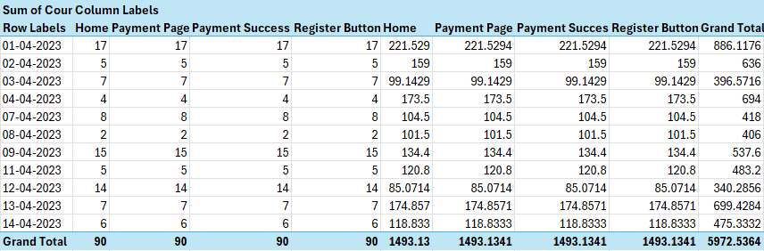

* + - Total users visited and Registered = 90 users
    - Maximum Registration = 17 users - 01April2023
    - Minimum Registration = 02 users - 08April2023
    - Maximum Avg time spent = 221.52(01April2023) - Total Users = 17 users
    - Minimum Avg time spent = 101.5(08April2023) - Total Users = 02 users
    - Maximum time spent in website = 886.1176(01April2023) – Total Users = 17 users
    - Minimum time spent in website = 340.28(12April2023) – Total Users = 14 users
    - Total time spent by 90 users = 5972.5364
    - Avg total time spent by 90 users = 66.36
    - Avg time spent on each page = 1493.13

**Registration Data Analysis and Insights**

* + **Total number of Registration with daily trend**

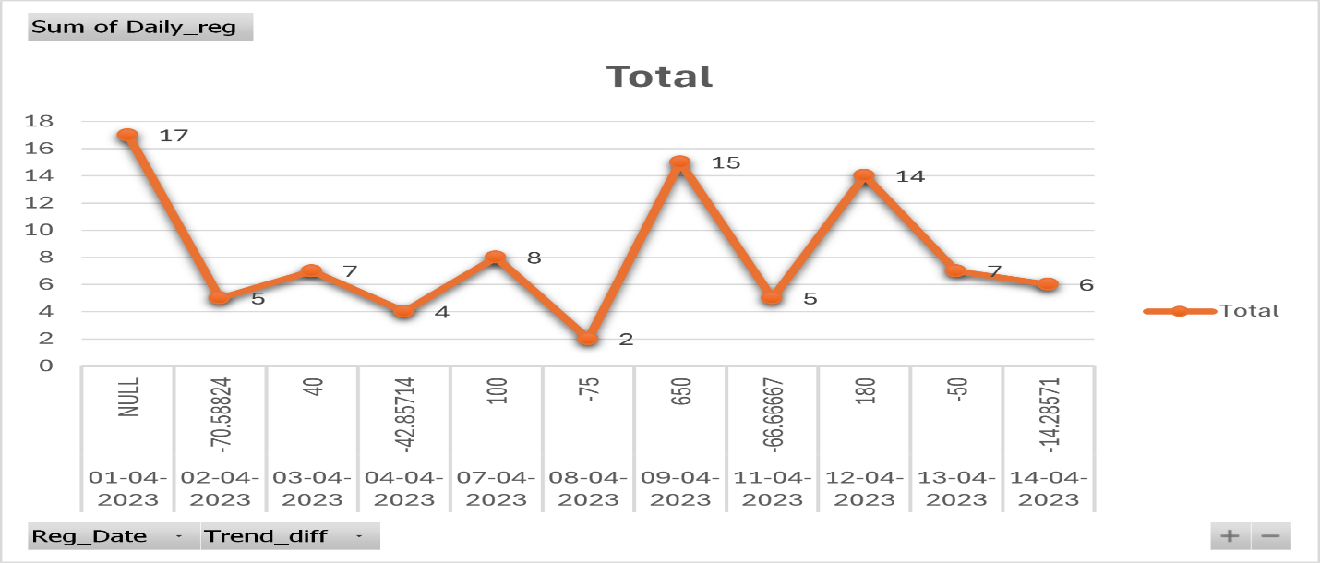

* + - Total users registered = 90 users
    - Highest Downfall in Registration = 02 users(08April2023)
    - Lowest Downfall in Registration = 01 user(14April2023)
    - Highest Peak in Registration = 17 users(01April2023)
    - Lowest Peak in Registration = 07 users(03April2023)
    - Highest +ve trend Difference = 02 users(08April2023) to 15 users(09April2023) : 650%
    - Lowest +ve trend Difference = 05 users(02April2023) to 07 users(03April2023) : 40%
    - Highest -ve trend Difference = 08 users(07April2023) to 02 users(08April2023) : 75%
    - Lowest -ve trend Difference = 07 users(13April2023) to 06 users(14April2023) : 14.28%
  + **Conversion Rates**

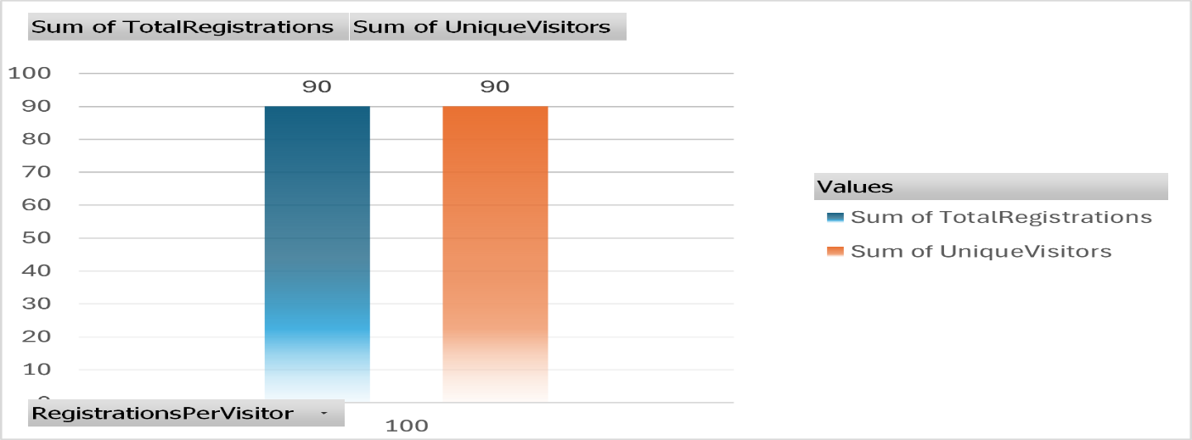

* + - Total no of unique visitors visited the course = 90 users
    - Total no of visitors registered the course = 90 users

**Course SB2(Statistics)**

* Registrations timeline - 17April2023 till 05May2023.
* Course Date – 06May2023
* Dataset to be used - may_data
* Analysis to be done - Website Traffic & Registration Data
* Date Range - Starting from 01May2023

**Data Cleaning and Preparation**

* + Removing NULL Values from CourseID Column in may_data
  + Adding 2 pages to visitedpages such as courses and course details to april_data to match with the visitedpages of may_data

**Website Traffic Analysis and Insights**

* + Daily Unique Visitors on Each Page and Avg time a user spent on each page

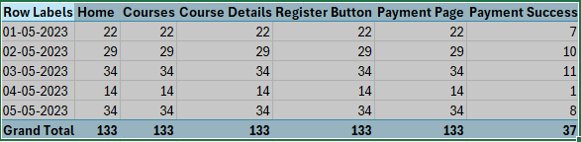

* + - Total users visited = 133 users
    - Total uses registered = 37 users
    - Maximum Registration = 10 users - 02May2023
    - Minimum Registration = 01 users - 04May2023

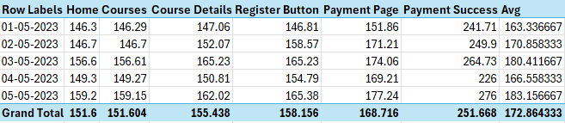

* Highest avg time spent by a user = 183.15(05May2023) - 08 users
* Lowest avg time spent by a user = 163.33(01May2023) – 07 users
* Avg time spent by 133 visiting users – 157.09
* Avg time spent by 37 registered users – 172.86

**Registration Data Analysis and Insights**

* + **Total number of Registration with daily trend**

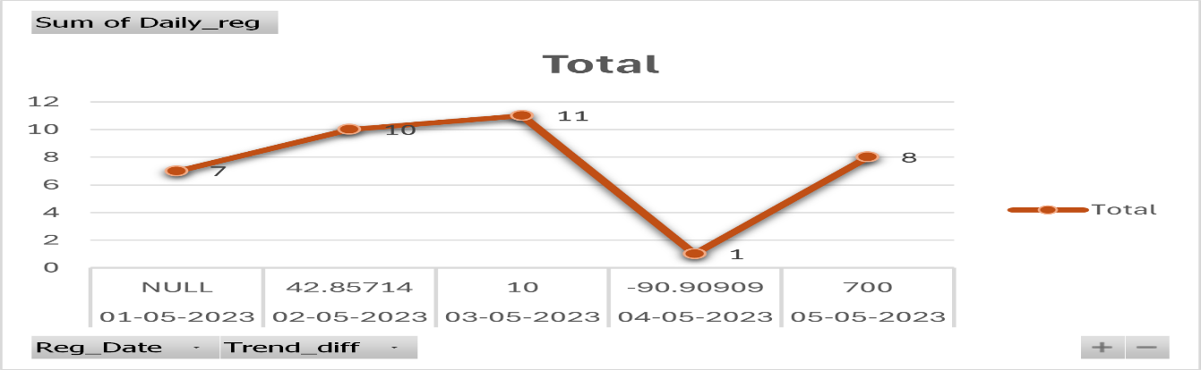

* + - Total users registered = 37 users
    - Highest Downfall in Registration = 01 users(04May2023)
    - Highest Peak in Registration = 08 users(05May2023)
    - Lowest Peak in Registration = 01 users(03Mayl2023)
    - Highest +ve trend Difference = 01 users(04May2023) to 08 users(05May2023) : 700%
    - Lowest +ve trend Difference = 10 users(02May2023) to 11 users(03May2023) : 10%
    - Highest -ve trend Difference = 11 users(03May2023) to 01 users(04May2023) : -90.9%
  + **Conversion Rates**

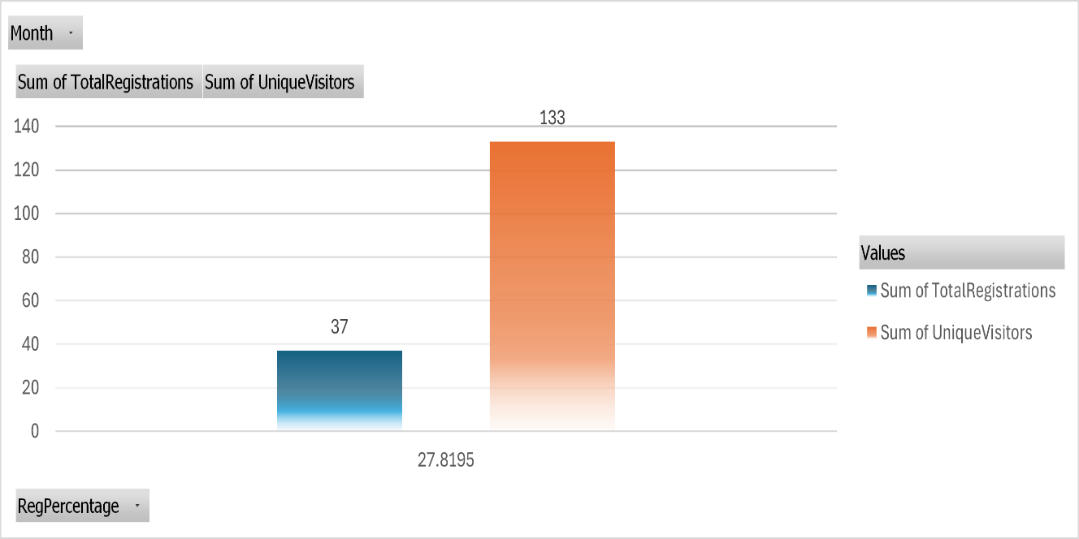

* + - Total no of unique visitors visited the course = 133 users
    - Total no of visitors registered the course = 37 users

**Course SB3(Statistics)**

* Registrations timeline – 01May2023 till 19May2023.
* Course Date – 20May2023
* Dataset to be used - may_data
* Analysis to be done - Website Traffic & Registration Data
* Date Range - Starting from 01May2023

**Website Traffic Analysis and Insights**

* + Daily Unique Visitors on Each Page and Avg time a user spent on each page

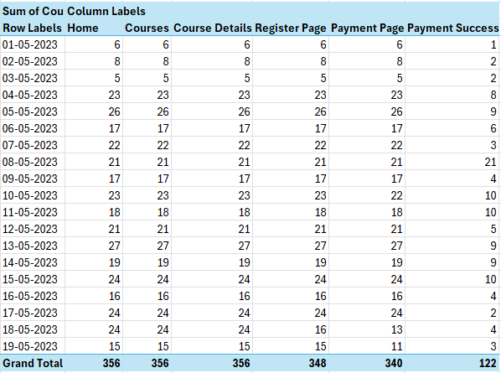

* + - Total users visited = 340 users
    - Total uses registered = 122 users
    - Maximum Registration = 27 users - 13May2023
    - Minimum Registration = 05 users - 03May2023

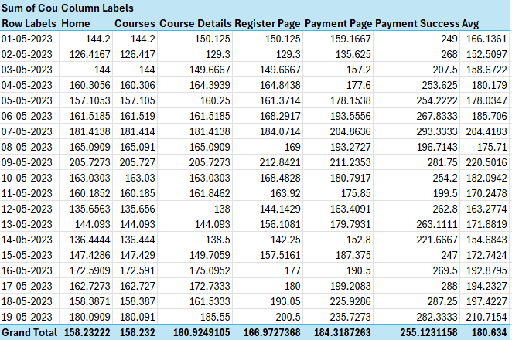

* Highest avg time spent by a user = 220.50(09May2023) - 04 users
* Lowest avg time spent by a user = 152.50(02May2023) – 02 users
* Avg time spent by 340 visiting users – 165.732
* Avg time spent by 122 registered users – 180.63

**Registration Data Analysis and Insights**

* + **Total number of Registration with daily trend**

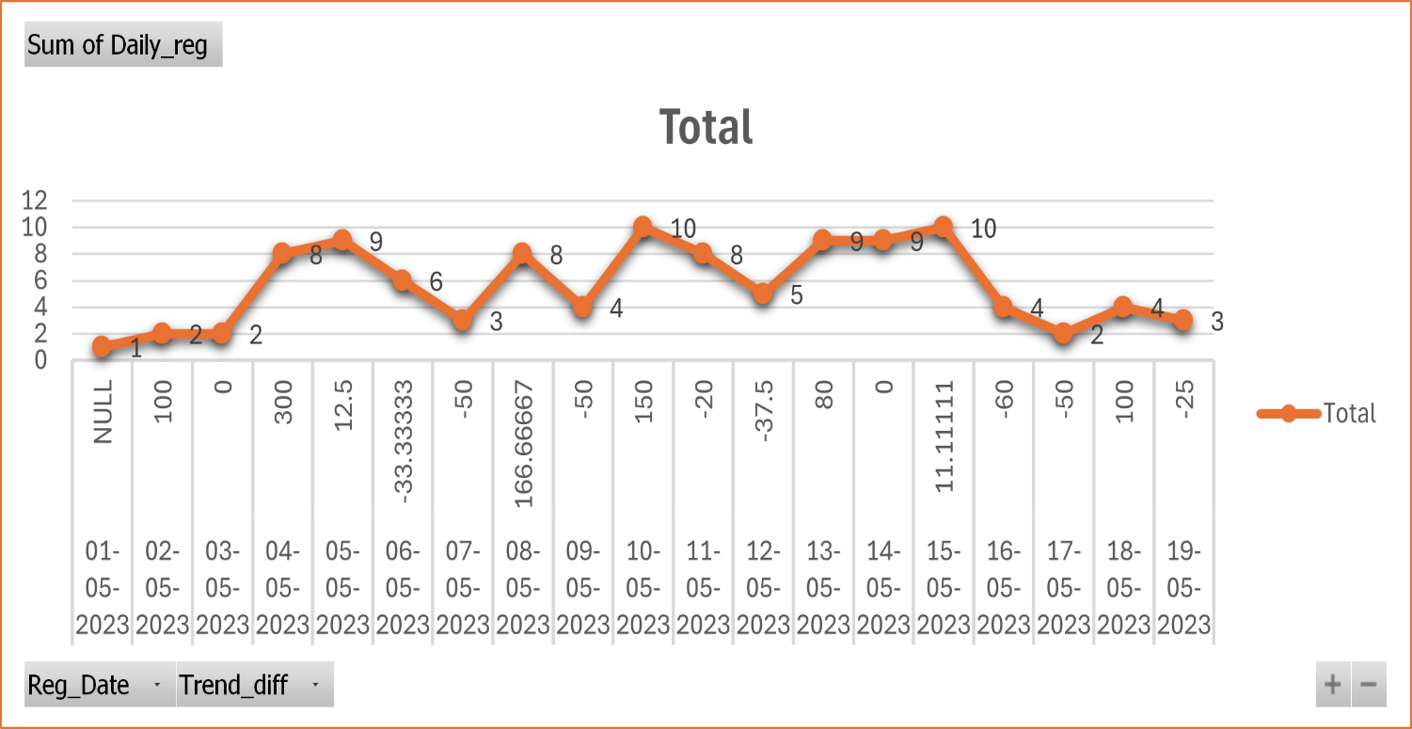

* + - Total users registered = 122 users
    - Highest Downfall in Registration = 04 users(16May2023)
    - Lowest Downfall in Registration = 08 user(11May2023)
    - Highest Peak in Registration = 08 users(04May2023)
    - Lowest Peak in Registration = 10 users(15May2023)
    - Highest +ve trend Difference = 02 users(03Mayl2023) to 08 users(04May2023) : 300%
    - Lowest +ve trend Difference = 09 users(14May2023) to 10 users(15May2023) : 11.11%
    - Highest -ve trend Difference = 10 users(15May2023) to 04 users(16May2023) : -60%
    - Lowest -ve trend Difference = 10 users(10May2023) to 08 users(11May2023) : -20%
  + **Conversion Rates**

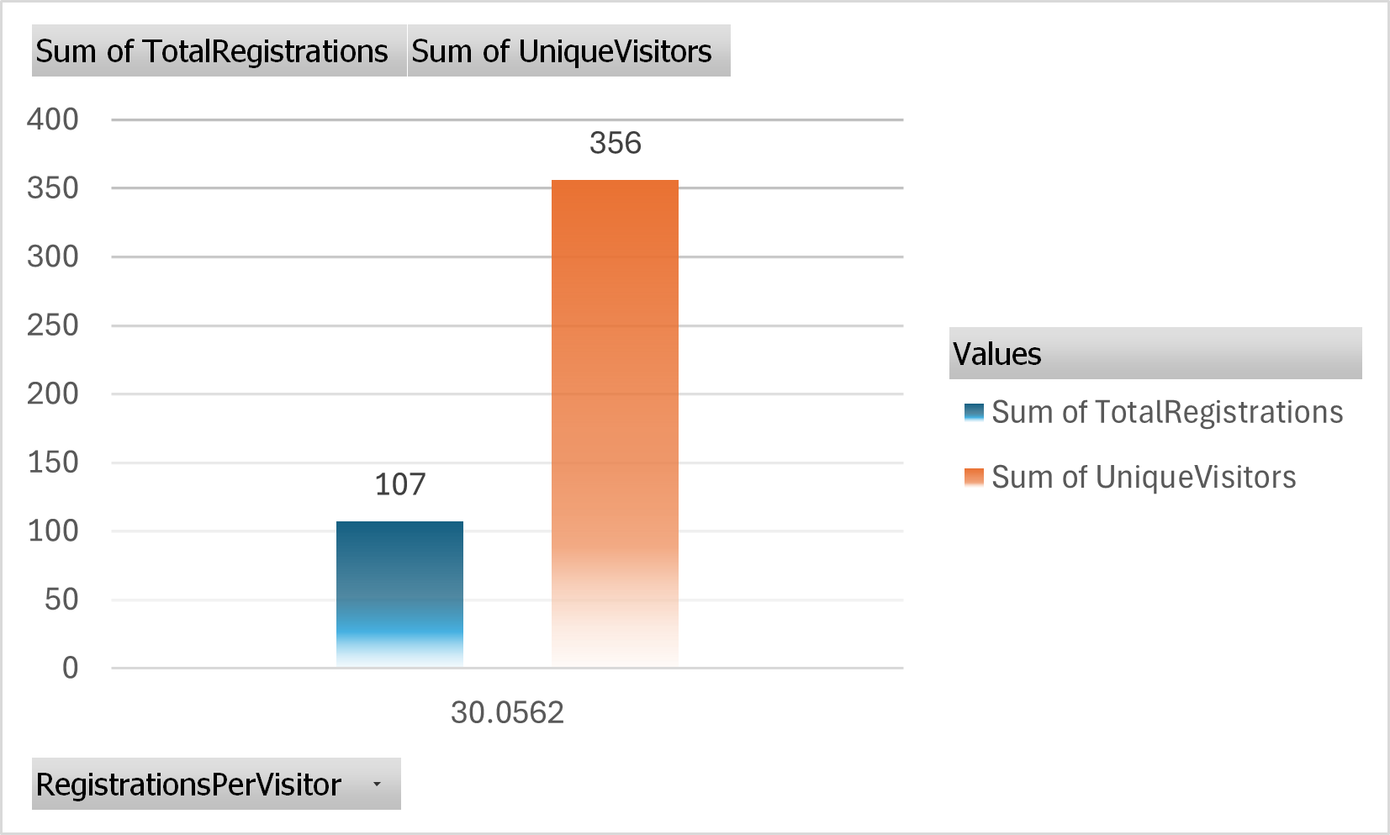

* + - Total no of unique visitors visited the course = 356 users
    - Total no of visitors registered the course = 107 users

**Course SB4(Statistics)**

* Registrations timeline – 22May2023 till 31May2023.
* Course Date – 03June2023
* Dataset to be used - may_data
* Analysis to be done - Website Traffic & Registration Data
* Date Range - Starting from 22May2023

**Website Traffic Analysis and Insights**

* + **Daily Unique Visitors on Each Page and Avg time a user spent on each page**

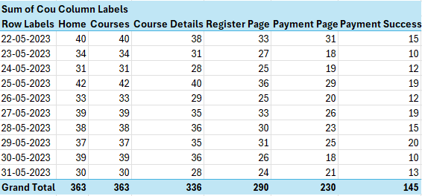

* + - Total users visited = 230 users
    - Total uses registered = 145 users
    - Maximum Registration = 20 users - 29May2023
    - Minimum Registration = 10 users - 23May2023 & 30May2023

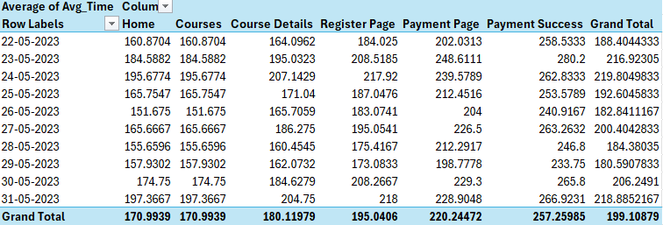

* Highest avg time spent by a user = 219.80(24May2023) - 12 users
* Lowest avg time spent by a user = 180.59(29May2023) – 20 users
* Avg time spent by 230 visiting users – 187.47
* Avg time spent by 145 registered users – 199.10

**Registration Data Analysis and Insights**

* + **Total number of Registration with daily trend**

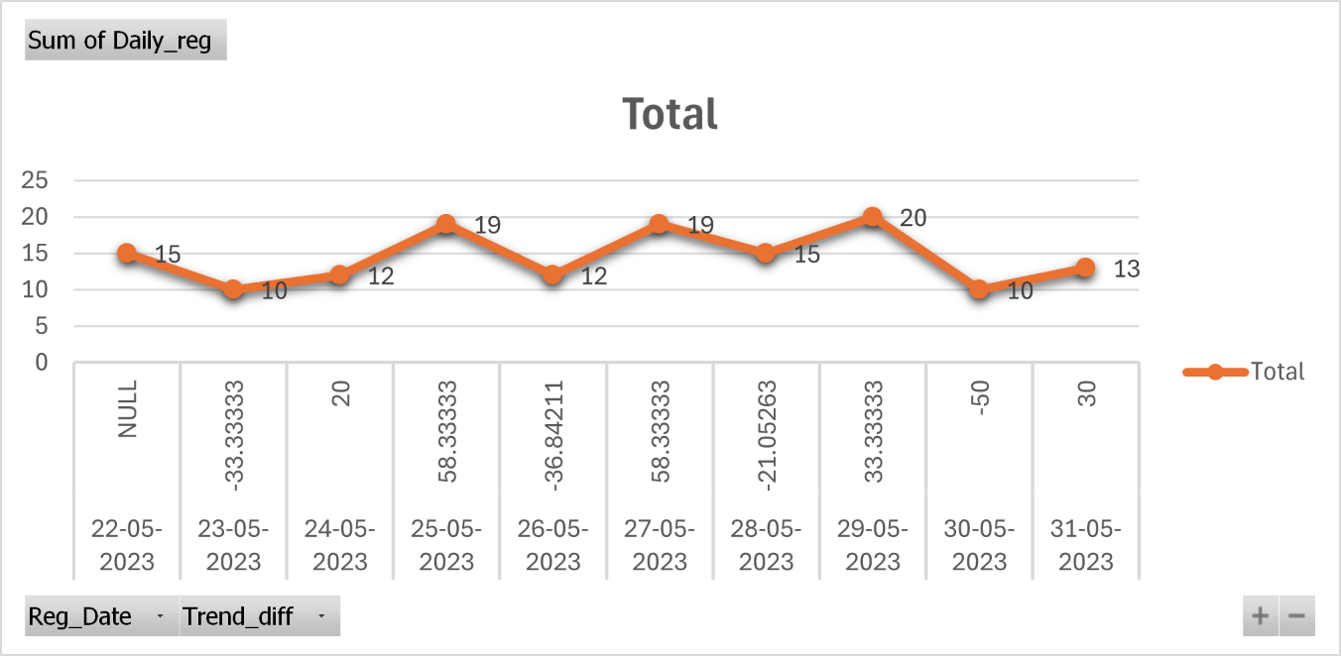

* + - Total users registered = 145 users
    - Highest Downfall in Registration = 10 users(30May2023)
    - Lowest Downfall in Registration = 15 user(28May2023)
    - Highest Peak in Registration = 38 users(25May2023 - 19 users) & (27May2023 - 19 users)
    - Lowest Peak in Registration = 12 users(24May2023)
    - Highest +ve trend Difference = 12 users(24May2023) to 19 users(25May2023) : 58.33% & 12 users (26May2023) to 19 users(27May2023) : 58.33%
    - Lowest +ve trend Difference = 10 users(23May2023) to 12 users(24May2023) : 20%
    - Highest -ve trend Difference = 20 users(29May2023) to 10 users(30May2023) : -50%
    - Lowest -ve trend Difference = 19 users(27May2023) to 15 users(28May2023) : -21%
  + **Conversion Rates**

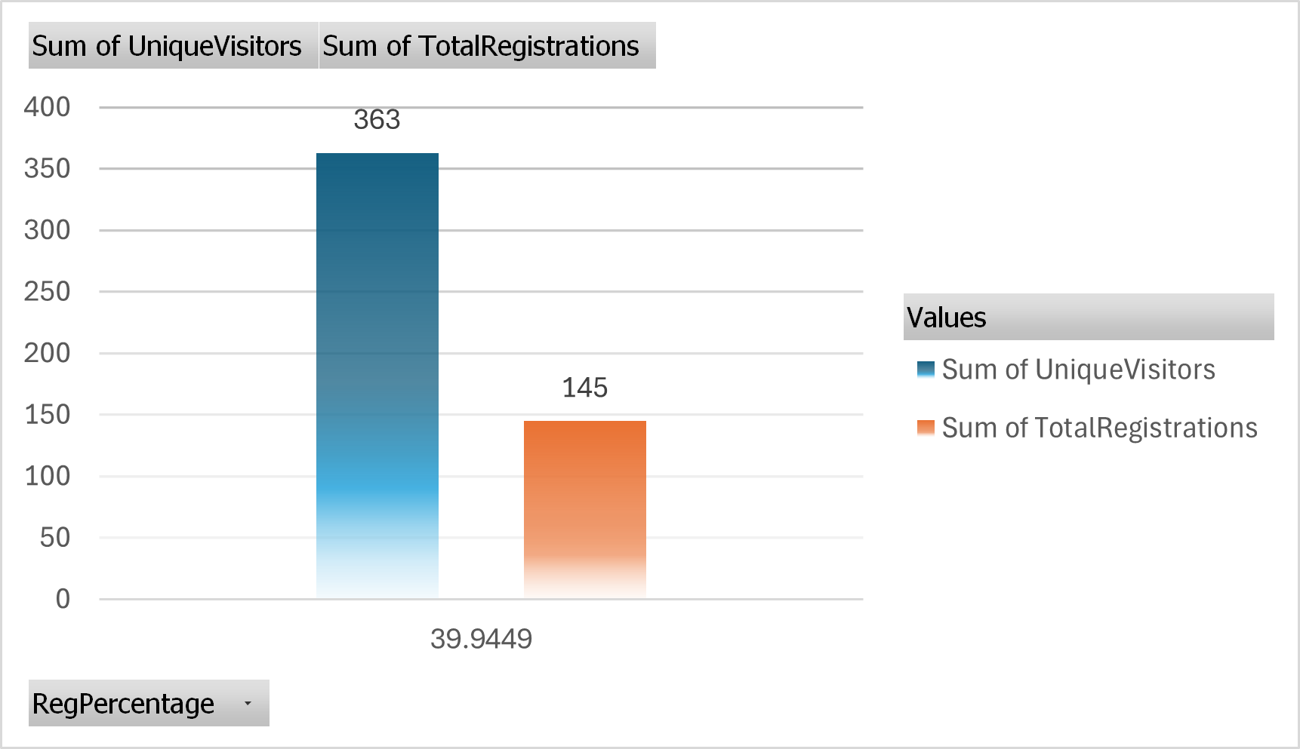

* + - Total no of unique visitors visited the course = 363 users
    - Total no of visitors registered the course = 145 users

**Marketing Analysis**

* Courses : Excel and SQL
* Timeline : 01June2023 to 18June2023
* Excel(EB1) : Facebook Ads(FB1) + Organic Visitors
* SQL(SQLB1) : Instagram(IG3) and Youtube(YT2) Ads + Organic Visitors
* Datasets to be used : campaign_metrics_june and campaigns
* Analysis to be done
* Click Through Rate(CTR)
* Cost per Click(CPC)
* Cost per Acquisition(CPA)
* Conversions

**Data Cleaning and Preparation**

* Removing NULL and Empty Values from CourseID Column
* Removing NULL values from CampaignId

**CTR**

* Total users clicked the AD and total users watched the AD
* **TOTAL CLICKS / TOTAL IMPRESSIONS**

**CPC**

* Total cost of the AD and Total clicks done on the AD
* **TOTAL COST / TOTAL CLICKS**

**CPA**

* Ratio of Product of Total no of registrations and course price and total number of registrations
* **TOTAL COST / TOTAL REGISTRATIONS**

**CONVERSION**

* Total no of registrations and total no of clicks on AD
* **TOTAL CONVERSIONS / TOTAL CLICKS**

**Excel**



* Among 25074 clicks only 2.14% clicks is used to register for Excel course through Facebook.
* 45.22 is the budget allocated for each click
* 71.42 is the budget allocated for each registration
* Among 25074 clicks only 63.31% clicks is used to register for the course

**SQL**



**Youtube**

* Among 139025 clicks 2.20% is used to register for SQL course through Youtube.
* 40.96 is the budget allocated for each click
* 68.82 is the budget allocated for each registration
* Among 139025 clicks only 59.51 clicks is used to register for the course

**Instagram**

* Among 43884 clicks 0.77% is used to register for SQL course through Instagram.
* 115.94 is the budget allocated for each click
* 192.77 is the budget allocated for each registration
* Among 43884 clicks only 60.14 clicks is used to register for the course

**Finance Analysis**

* Courses : Statistics,Excel and SQL
* Timeline : 01April2023 to 18June2023
* Statistics(S1B1,SB2,SB3,SB4)
* Excel(EB1) : Facebook Ads(FB1) + Organic Visitors
* SQL(SQLB1) : Instagram(IG3) and Youtube(YT2) Ads + Organic Visitors
* Datasets to be used : april_data,may_data,June_data,course_price and marketing data

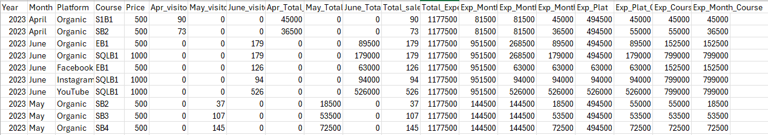

* **Total expenditure of all courses is 1177500**

**Monthwise**

* **April**
  + **Organic**
* Course S1B1 and SB2 has 90 and 73 visitors respectively.
* Total sales of 45000 and 36500 for S1B1 and SB2 respectively
* Total expenditure of 81500 for S1B1 and SB2
* **May**
  + **Organic**
    - Course SB2,SB3 and SB4 has 37,107 and 145 visitors respectively.
    - Total sales of 18500,53500 and 72500 for SB2,SB3 and SB4 respectively
    - Total expenditure of 144500 for SB2,SB3 and SB4
* **June**
* Total Expenditure of 951500 for SQLB1 and EB1
  + **Organic**
    - Course EB1 and SQLB1 has 179 and 179 visitors respectively.
    - Total sales of 89500 and 179000 for EB1 and SQLB1 respectively
    - Total expenditure of 268500 for EB1 and SQLB1
* **Facebook**
* Course EB1 has 126 visitors
* Total sales of 63000 for EB1
* Total expenditure of 63000 for EB1
* **Instagram**
  + Course SQLB1 has 94 visitors
  + Total sales of 94000 for SQLB1
  + Total expenditure of 94000 for SQLB1
* **Youtube**
  + Course SQLB1 has 526 visitors
  + Total sales of 526000 for SQLB1
  + Total expenditure of 526000 for SQLB1

**Platformwise**

* Organic – 494500
* Facebook – 63000
* Instagram – 94000
* Youtube – 526000

**Coursewise**

* S1B1 – 45000
* SB2 – 55000
* SB3 – 53500
* SB4 – 72500
* EB1 – 152500
* SQLB1 – 799000

**Platformwise and Coursewise**

* **Organic**
* S1B1 – 45000
* SB2 – 55000
* SB3 – 53500
* SB4 – 72500
* EB1 – 63000
* SQLB1 – 179000
* **Facebook**
* EB1 – 63000
* **Instagram**
* SQLB1 – 94000
* **Youtube**
  + SQLB1 – 526000

**Product Analysis – Versions**

* Courses : DAIB1
* Timeline : 01July2023 to 15July2023
* Datasets to be used : campaign_metrics_july, july_data_20230715 and campaigns
* Analysis to be done
* Click Through Rate(CTR)
* Cost per Click(CPC)
* Cost per Acquisition(CPA)
  + Conversions

**Data Cleaning and Preparation**

* + Removing NULL values from CourseID Column in july_data_20230715 table

**Visiting Traffic analysis and insights-Variant A**

* + **Visited and Registered**

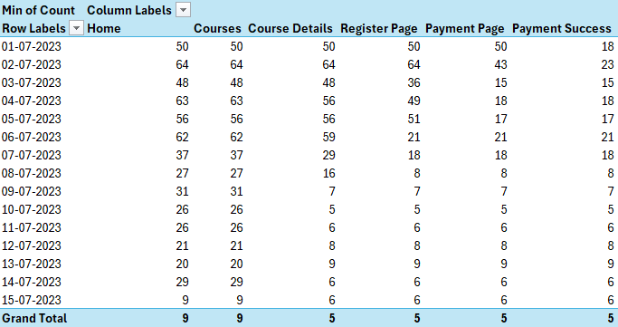

* Total users visited = 425 users
* Total uses registered = 185 users
* Maximum Registration = 23 users - 02July2023
* Minimum Registration = 05 users – 10July2023
* **Avg Time**

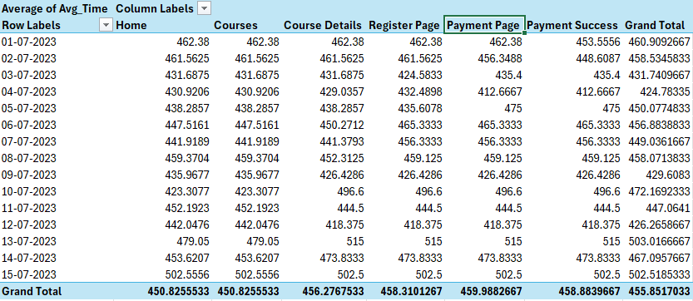

* + - Maximum Avg time spent = 503.01(13July2023) - Total Users = 09 users
    - Minimum Avg time spent = 424.78(04July2023) - Total Users = 18 users
    - Maximum time spent in website = 3015.11(15July2023) – Total Users = 09 users
    - Minimum time spent in website = 2548.70(04July2023) – Total Users = 18 users
    - Total time spent by 425 users = 41026.65
    - Avg total time spent by 425 users = 455.85

**Visiting Traffic analysis and insights-Variant B**

* **Visited and Registered**

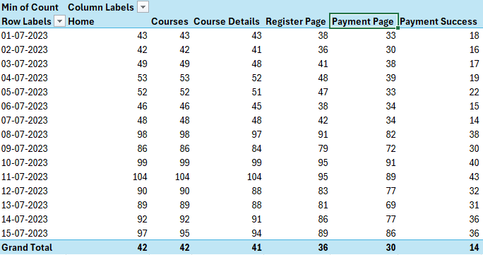

* Total users visited = 1088 users
* Total uses registered = 407 users
* Maximum Registration = 43 users - 11July2023
* Minimum Registration = 14 users – 07July2023
* **Avg time**

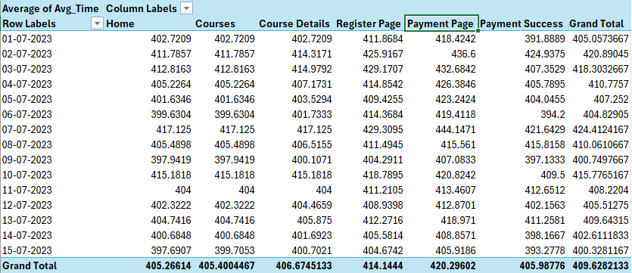

* + - Maximum Avg time spent = 424.41(07July2023) - Total Users = 14 users
    - Minimum Avg time spent = 400.32(15July2023) - Total Users = 36 users
    - Maximum time spent in website = 2546.47(07July2023) – Total Users = 48 users
    - Minimum time spent in website = 2401.96(15July2023) – Total Users = 97 users
    - Total time spent by 1088 users = 36866.53
    - Avg total time spent by 407 users = 405.98

**Registration Data with Daily Registration Trends – Variant A**

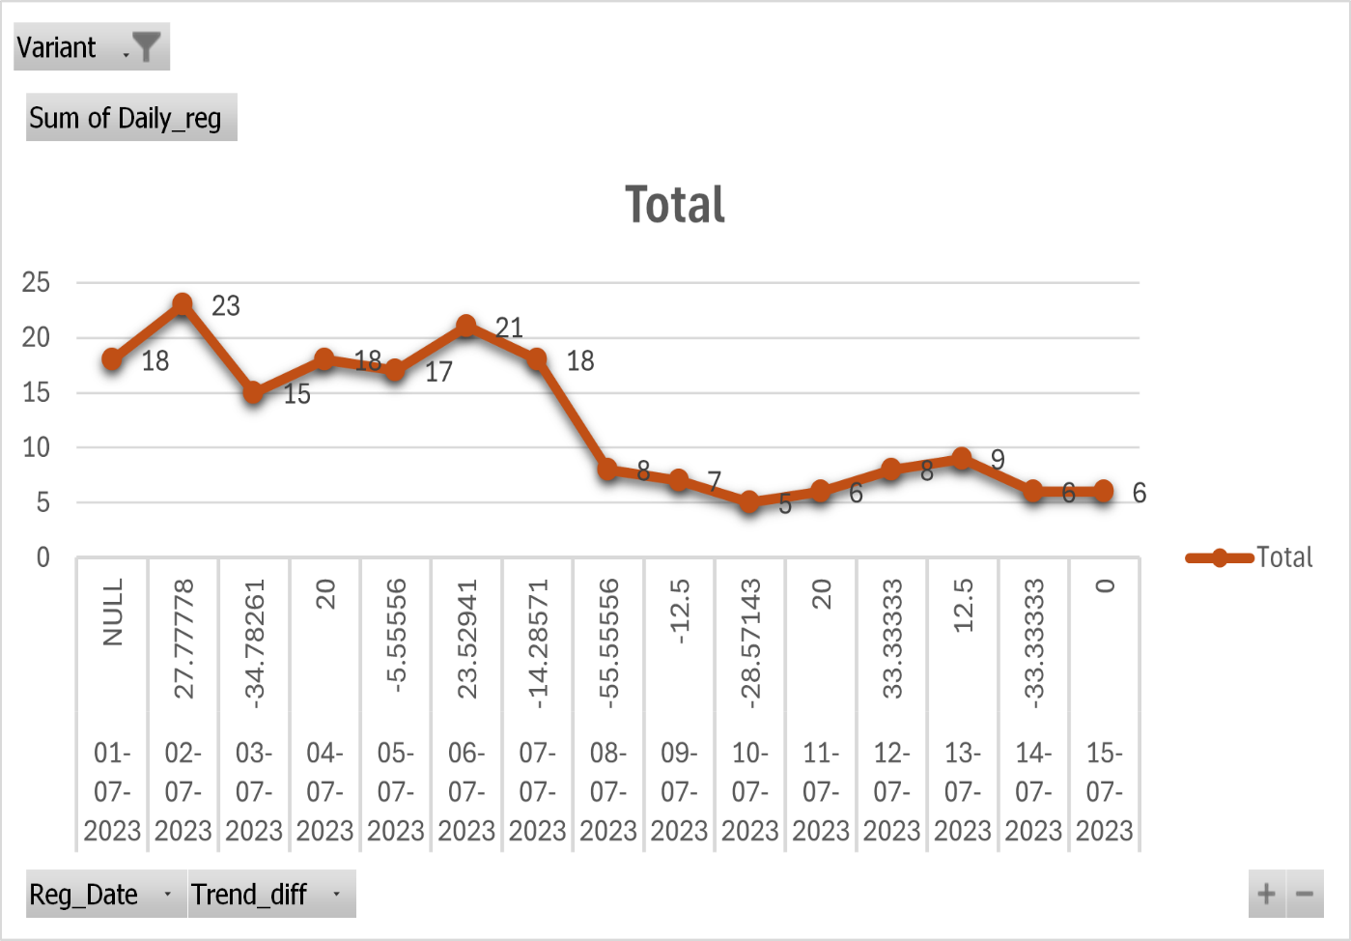

* + - Total users registered = 185 users
    - Highest Downfall in Registration = 05 users(10July2023)
    - Lowest Downfall in Registration = 21 users(06july2023)
    - Highest Peak in Registration = 23 users(01July2023)
    - Lowest Peak in Registration = 09 users(13July2023)
    - Highest +ve trend Difference = 18 users(01July2023) to 23 users(02July2023) : 27.77%
    - Lowest +ve trend Difference = 08 users(12July2023) to 09 users(13July2023) : 12.5%
    - Highest -ve trend Difference = 18 users(07July2023) to 08 users(08July2023) : -55.55%
    - Lowest -ve trend Difference = 18 users(04July2023) to 17 users(05July2023) : -5.55%

**Registration Data with Daily Registration Trends – Variant B**

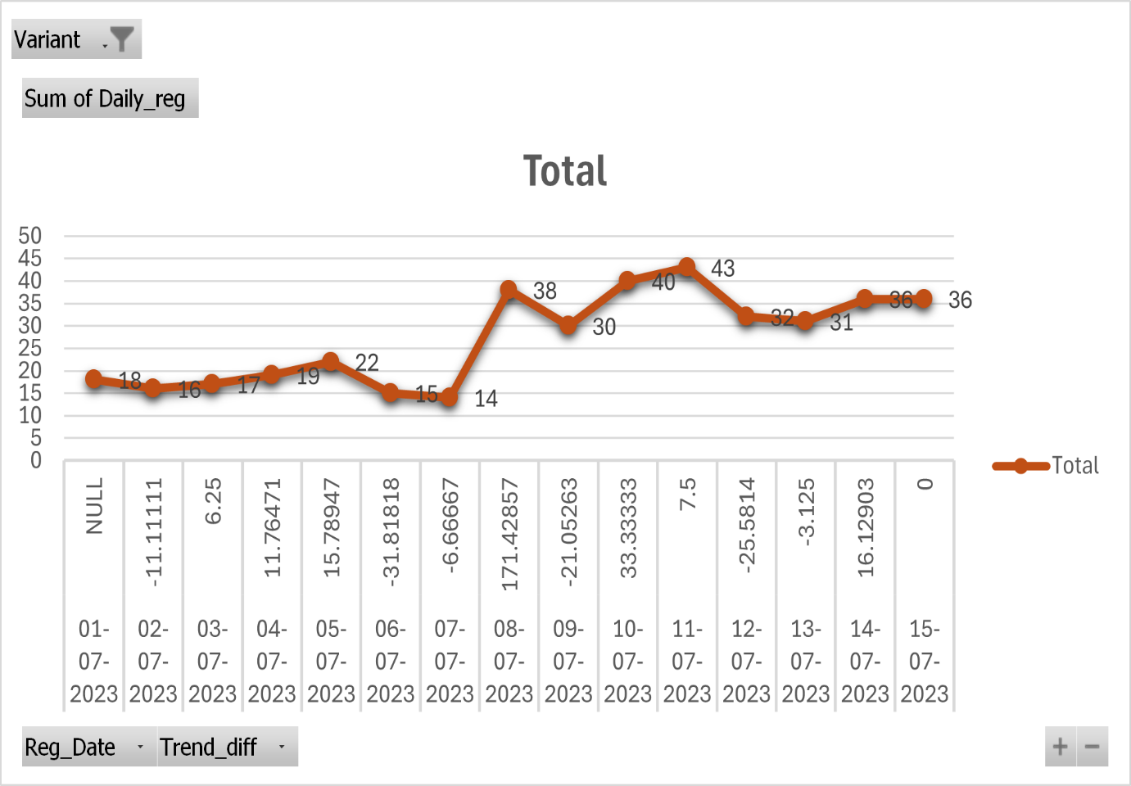

* + - Total users registered = 407 users
    - Highest Downfall in Registration = 14 users(07July2023)
    - Lowest Downfall in Registration = 31 users(13july2023)
    - Highest Peak in Registration = 43 users(11July2023)
    - Lowest Peak in Registration = 17 users(03July2023)
    - Highest +ve trend Difference = 14 users(07July2023) to 38 users(08July2023) : 171.42%
    - Lowest +ve trend Difference = 16 users(02July2023) to 17 users(03July2023) : 6.25%
    - Highest -ve trend Difference = 22 users(05July2023) to 15 users(06July2023) : -31.81%
    - Lowest -ve trend Difference = 32 users(12July2023) to 31 users(13July2023) : -3.12

**Conversion rates**

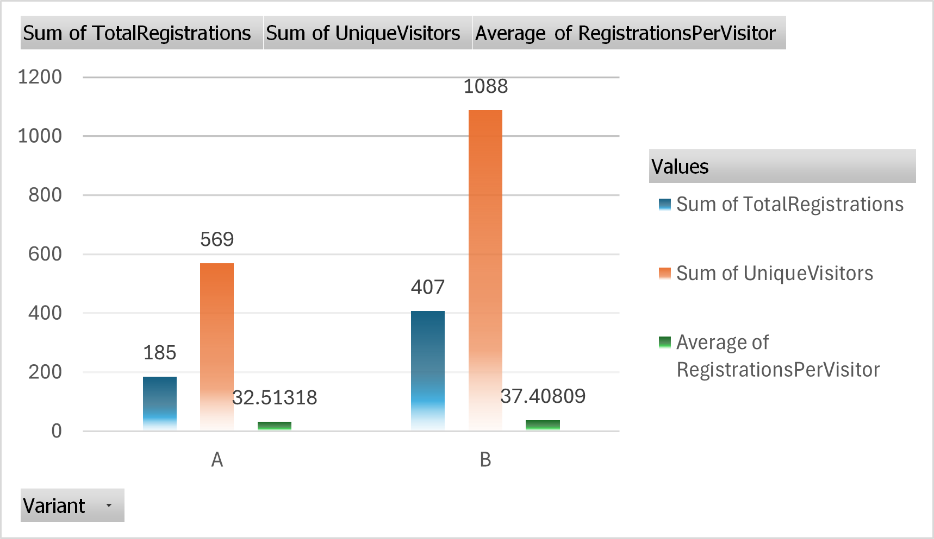

* + - Total no of unique visitors visited in Variant A = 569 users
    - Total no of visitors registered in Variant A = 185 users
    - Percentage of users registered in variant A = 32.51
    - Total no of unique visitors visited in Variant B = 1088 users
    - Total no of visitors registered in Variant A = 407 users
    - Percentage of users registered in variant b = 37.40

**CTR,CPC,CPA and Conversion**



Variant A

* Among 372 clicks only 2.21% clicks is used to register for DAIB1 course through Youtube.
* 40.32 is the budget allocated for each click
* 144.23 is the budget allocated for each registration
* Among 372 clicks only 27.95% clicks is used to register for the course

Variant B

* Among 371 clicks only 2.18% clicks is used to register for DAIB1 course through Youtube.
* 40.43 is the budget allocated for each click
* 56.81 is the budget allocated for each registration
* Among 371 clicks only 71.15% clicks is used to register for the course

**Comprehensive Analysis**

* **Drop rates**
* **Conversion rates**